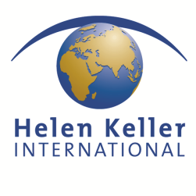
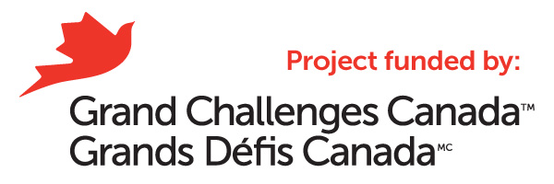

JOB TITLE

Consultancy for production of a short film/video about HKI’s ChildSight®

in Kon Tum, Viet Nam

TERMS OF REFERENCE

Background

Helen Keller International (HKI) is an international non-governmental organization. Its mission is to save the sight and lives of the most vulnerable and disadvantaged by combating the causes and consequences of blindness and malnutrition. We do this by establishing programs grounded in evidence-based research in eye health and nutrition.
Uncorrected refractive errors are a significant cause of avoidable visual impairment, blindness and disability, especially in developing countries. HKI’s ChildSight® program in Vietnam has been successfully implemented in Kon Tum Province. The goal of the program is to improve the academic potential of young children by removing the basic barriers that prevent them from obtaining proper primary eye care: limited access and prohibitive cost. To address these barriers, ChildSight® screens primary and secondary school children for vision problems, identifies those who are in need of glasses, and provides them with proper prescription glasses. Communication and educational activities, aimed at increasing awareness of students, teachers and parents, are indispensable and central components of the ChildSight® program.
With the generous support from Grand Challenges Canada, HKI implement the program called “Integrating private optic shops into HKI’s ChildSight® program to improve school-based vision services in Kon Tum Province, Vietnam”.
Objectives of program:
- Establish a sustainable system for school-based vision screening and the provision of free quality eyeglasses to poor students;
- Enhance the capacity of community health and school staff to screen, identify and refer children with eye health problems;
- Reduce the number of children with uncorrected refractive errors by screening, refracting and providing free eyeglasses to all children who need them in 16 target schools;
- Improve the knowledge of teachers, students, parents and community members about the importance of maintaining good vision for all family members;
- Improve the capacity of private optic shops in Kon Tum to provide high quality eyeglasses for those who have refractive errors.
So far 12,175 schoolchildren in 35 primary and secondary schools in Kon Tum city, Dak Ha and Dak To districts within Kon Tum Province, Vietnam have been screened. Over 13,630 leaflets and 33 posters were produced and distributed to children and teachers both in these schools. Art competitions among intervention schools were organized to encourage thousands of school kids to express their thoughts and ideas on how to keep their eyes healthy.
Through this project, private optic shops were provided with hands-on training to improve their product quality thereby contributing to improved children's vision. By cooperating with Vietnam National Institute of Ophthalmology to provide this training course, it is expected that district level in Kon Tum Province will have qualified optic shops that can provide quality eyeglasses to children who have refractive errors, especially those in remote areas who could not access such services before.

As part of the communication activities, HKI would like to invite professional filmmakers to produce a short video film about HKI’s program in Kon Tum.

Goal and objectives of the consultancy:
The end goal of the consultancy is to produce an effective video on HKI’s ChildSight ® in Kon Tum province, Viet Nam, its best practice, lessons learnt and the potential investment opportunities is has on offer.

Requirements for the video:
- Should reflect the project activities and its achievements, especially to increase awareness about refractive errors
- Should be able to give some recommendations for difference audiences including students, teachers and partners

SCOPE OF WORK
In carrying out the consultancy, the successful filmmakers shall undertake the following key tasks:
- Review the existing materials and publications on investment promotion and consult with relevant stakeholders
- Develop a concept, story board and script for the video with proposals on ideal duration for the video
- Finalize the design/direction and production of the video presentation. Sourcing of relevant video footage, photography, narration, etc. will be the responsibility of the designer
- Carry out the design and production of the video, Vietnam. Sourcing of relevant video footage, photography, narration
- Go to Kon Tum Province in 3rd week of May to film project activities.

DELIVERABLES
- A quality video with the requirements mentioned above
TIMEFRAME:
Tentative timeline: March 2014
- Review, Design and produce script: week 2, March 2014
- Field trip: 3rd week of March in Kon Tum province, Vietnam
- Production and editing: April-May 2014
Qualification requirements:
Experience:
- Minimum 5 years of recognized expertise in mass media
- Proven multimedia design and artistic skills preferred
- Experience in development in Viet Nam, especially in child health care
- Gender equity
- Fluency in English and Vietnamese language

Budget: The fee for consultant will be negotiated and applied following HKI Vietnam regulations.
The interested consultant or consultancy companies, please submit:
- A letter of interest;
- CV
- Financial Proposal;
- Supporting documents (if any)

To:
Helen Keller International Vietnam
Room 103, B5 building, Van Phuc Diplomatic Compound,
298 Kim Ma, Hanoi, Vietnam

Email: dlam@hki.org ; sondinh@hki.org and Cc: pngoc@hki.org
The deadline for submitting the application will be on 6 March 2014.
Only short-listed consultants will be contacted.

